Personal Portfolio 2 - IFB299

－ Application Design and Development －

In the process of release 2, our team focuses on adding some features to the site to help both user types get things done quicker. Therefore, I complete some user stories and help my team to implement these functions. In addition, I have done some test cases and recorded it. This website still has some bugs and further work, which need to be fixed in the future. I also invited my friends to test this website, and I consider the business model of this website as well.

Artefact 1: user stories

I suggest the history of migrant and volunteer are necessary to be added. Because for the migrant, if he or she want to view their job history to get the contact details of previous contractors, they can find it in the job’s history, and for the volunteer, if he or she want to try a new job, they can view the history and see what they have done before. Finally, our teammates agreed that we should add the migrant’s history in the websites, but the volunteer’s history was still being considered. I also suggest multi-language should be created for migrant. I still suggested that if volunteer don’t know how to do a shift and want to change the roster, they could submit a request to manager so that they can deal with it.

|  |  |  |  |  |  |
| --- | --- | --- | --- | --- | --- |
| **Story ID** | **Summary** | **Description** | **Points** | **Sprint** | |
| 20 | Volunteer send requests for changing roster | As a volunteer I would like to be able to submit requests to change the roster If I can not do a shift | 4 | 4 | |
| 16 | Migrant ：Account history | As a migrant I want to have job history stored in my account, this will allow me to potentially call back a good contractor that was understanding last time  Acceptance Criteria: Migrant is able to view their job history and contact details of previous contractors | 8 | 3 | |
| 14 | Migrant： Lodge Request in multi language requests | As a migrant I want to be able to lodge a request in my own language, as this would make it easier for myself to go more in depth with the problem.  Acceptance Criteria: Migrant is able to change the language of the page by selecting their language from a dropdown list. | 2 | | 3 |

Artefact 2 test cases

I create some excels to test the website and recorded it. The document is in the folder, and the following are the screenshot of the document.

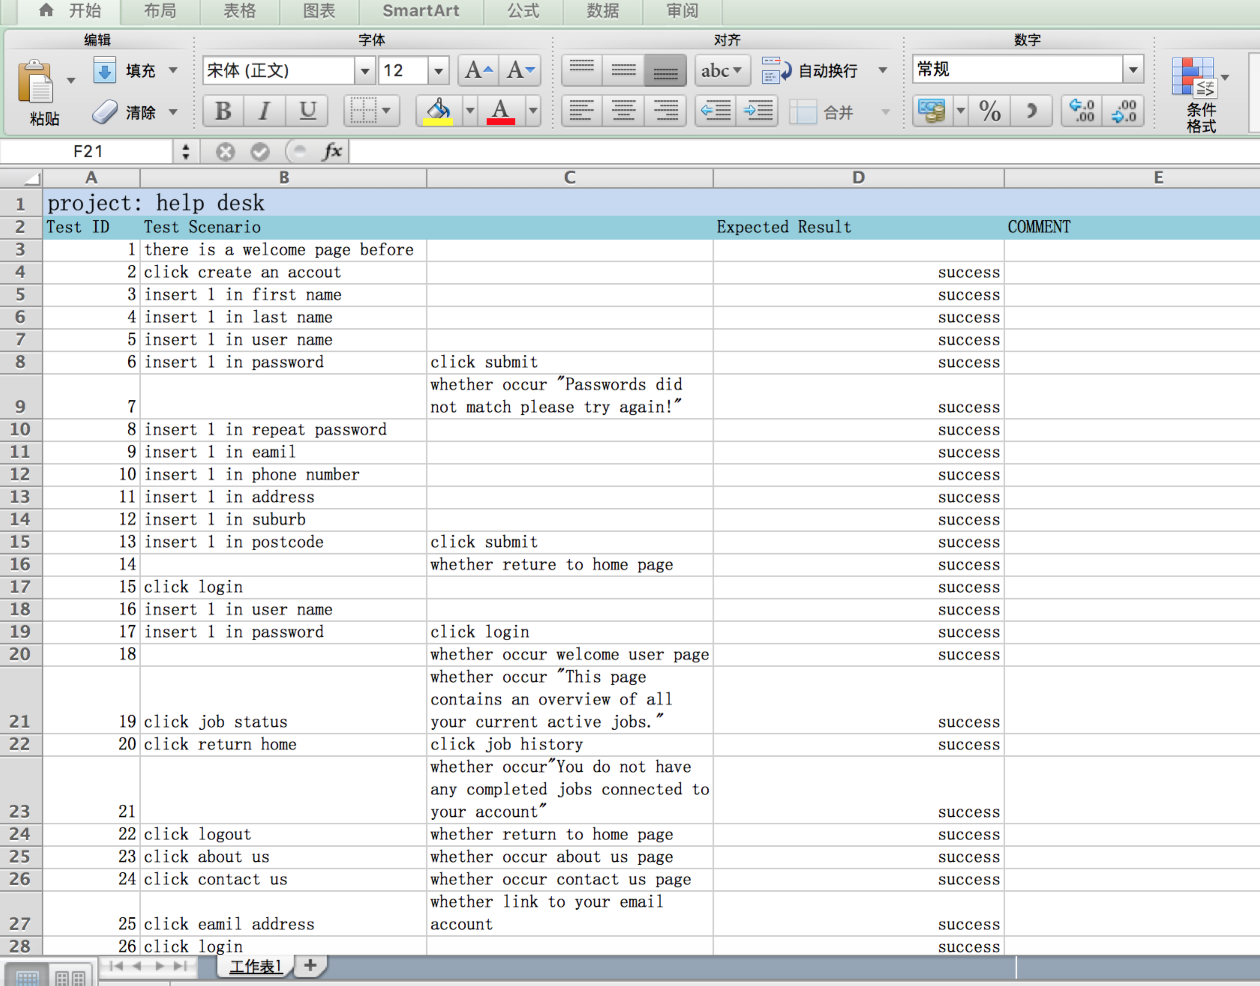

Artefact 3: find bugs and report it

When I test the website, I find

1. if user go to the “ create an account page”, and insert a username which hasn’t been used before, and click “ submit”, it still will show “***Username already taken. Please try again.***”
2. If user go to the “ create an account page”, and insert a username and last name and user name, which haven’t been used before, then click the “submit ”, it still can work and show the “***Account Created Successfully!***”
3. If users create a volunteer account, when they want to login in this website, it will demonstrate “***User is not approved***”.

Artefact 4: feedback from potential users

I also let my friends to test our website. Most of them thought that our websites is quite simple, and suggest that we should add some images in the main page, which is efficient to attract more users. Some function and further hasn’t been completed, such as the volunteer sign up page, whatever users create in that page, they can not get any response if users only fix no more 4 information. I also got the feedback that the password doesn’t has a limited, which include the number of word and type of word.

Artefact 5: business model

This website is an ideal place for migrants and volunteers to find a job. Initially, the help desk website can be used by unemployment people. As we all known, there are more and more individuals are facing the unemployment. These kinds of people are hard to find a new job and almost no opportunities to get some information about a new job. Nowadays, many unemployment people like to search for a job though walking in companies, which is inconvenient and unfair. Through this website, users can upload their personal information. Then, the managers can arrange them to a new job, which is matched with their information. There are some plans for the website to make benefit. We can charge some fees if users find new work, and create VIP account for users who want to find a new job as soon as possible. The VIP account can be achieved if users make a payment. We also can make some advertisements on the website.